Dear Year 7 Students and Parents,

Welcome to Bentleigh Secondary College. We are excited to welcome our new Year 7 students as they begin their journey with us tomorrow.

What to Bring

On the first day, Wednesday 28th January, students will only need to bring a pencil case, lunch or money for the canteen, a water bottle. The school will provide all other required resources.

From Thursday 29th January, students may begin bringing additional items such as textbooks and exercise books. By this time, all students will have been allocated lockers, providing a secure place to store their belongings.

ICT Devices

Students will not need their laptops for the first two weeks of school. We will begin connecting laptops to the school network after we return from camp. We have been required to adjust our ICT onboarding schedule for the Year 7 group, due to the Education Department ICT issues that occurred over the school holidays. Further information regarding ICT connections and camp arrangements will be shared later.

First Day Schedule

Students should arrive by 8.50 am for a 9:00 am start and assemble in the Performing Arts Precinct for a welcome session. They will then be escorted by their teachers to their homerooms. Please note that parents are not expected to remain for the welcome session. Attached is a list of scheduled activities for the first day.

Uniform for School Photos

Students are required to wear the Term 1 uniform, which includes

- School Blazer
- White socks
- Black Leather shoes
- Either
o White shirts with navy pants or shorts
o School Dress

Below is a diagram showing the Term 1 uniform.

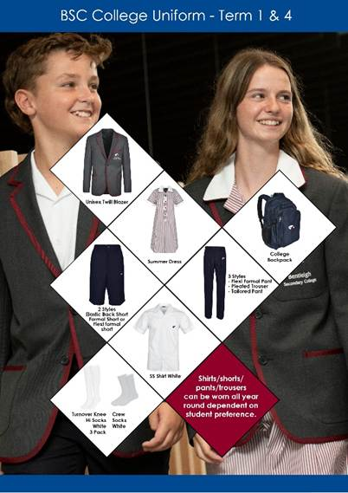

Students do not need to wear a tie, as ties are only worn during Terms 2 and 3.
We look forward to a wonderful start to the year and warmly welcome you to our school community.
Kylie Dark
Head of Junior School

Marie Mulhair
Head of Year 7

